Circle Language Spec: Commands

Inactive Clauses in a Command Definition in a Diagram
This article demonstrates a situation of command objects.

This article illustrates how inactive clauses in a command definition look in a diagram.

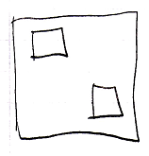

The larger square is a command definition. The smaller squares inside the larger square are inactive clauses inside a command definition. Squares inside a square, that do not redirect, are inactive clauses.

